# Statistical Thinking Diagrams and Models

A page where Chris Wild's various models and diagrams of aspects of statistical thinking accumulate

**From:**Pfannkuch, M., Regan, M., Wild, C. and Horton, N.J. (2010) [Telling Data Stories: Essential Dialogues for Comparative Reasoning](http://www.amstat.org/publications/jse/v18n1/pfannkuch.pdf). **Journal of Statistics Education**, 18(1).

[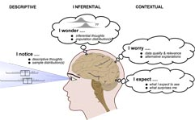](https://www.stat.auckland.ac.nz/~wild/StatThink/images/10.Triggers.col.png)

**Looking at data**

Download as a [png](https://www.stat.auckland.ac.nz/~wild/StatThink/images/10.Triggers.col.png)

or an [eps](https://www.stat.auckland.ac.nz/~wild/StatThink/images/10.Triggers.col.eps)

**From:**Forster, M. and Wild, C. Writing about findings: Integrating teaching and assessment. In, **Assessment Methods in Statistical Education**, P. Bidgood, N. Hunt and F. Joliffe (eds), West Sussex: Wiley, 87 � 102, 2010.

[Thumbnail](https://www.stat.auckland.ac.nz/~wild/StatThink/images/10.DataAnal2.png)

**Data analysis cycle**  
Download as a [png](https://www.stat.auckland.ac.nz/~wild/StatThink/images/10.DataAnal2.png)or an [eps](https://www.stat.auckland.ac.nz/~wild/StatThink/images/10.DataAnal2.eps)

**From:**: Wild, C.J. and Pfannkuch, M. (1999)  ["Statistical thinking in empirical enquiry"](http://www.stat.auckland.ac.nz/~iase/publications/isr/99.Wild.Pfannkuch.pdf) (with discussion). **International Statisitical Review**, 67, 221-266.

[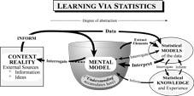](https://www.stat.auckland.ac.nz/~wild/StatThink/images/99.Learning.png)

**Learning via statistics**

Download as a [png](https://www.stat.auckland.ac.nz/~wild/StatThink/images/99.Learning.png)or an [eps](https://www.stat.auckland.ac.nz/~wild/StatThink/images/99.Learning.eps)

[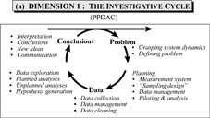](https://www.stat.auckland.ac.nz/~wild/StatThink/images/99.Investigative.png)

**Investigative Cycle**  
(Statistical investigation cycle/PPDAC cycle)

Download as a [png](https://www.stat.auckland.ac.nz/~wild/StatThink/images/99.Investigative.png) or an [eps](https://www.stat.auckland.ac.nz/~wild/StatThink/images/99.Investigative.eps)

[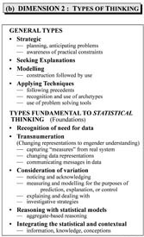](https://www.stat.auckland.ac.nz/~wild/StatThink/images/99.Types.png)

**Types of Thinking**

Download as a [png](https://www.stat.auckland.ac.nz/~wild/StatThink/images/99.Types.png) or an [eps](https://www.stat.auckland.ac.nz/~wild/StatThink/images/99.Types.eps)

[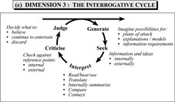](https://www.stat.auckland.ac.nz/~wild/StatThink/images/99.Interrogative.png)

**Interrogative Cycle**

Download as a [png](https://www.stat.auckland.ac.nz/~wild/StatThink/images/99.Interrogative.png) or an [eps](https://www.stat.auckland.ac.nz/~wild/StatThink/images/99.Interrogative.eps)

[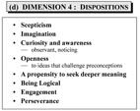](https://www.stat.auckland.ac.nz/~wild/StatThink/images/99.Dispositions.png)

**Dispositions**

Download as a [png](https://www.stat.auckland.ac.nz/~wild/StatThink/images/99.Dispositions.png) or an [eps](https://www.stat.auckland.ac.nz/~wild/StatThink/images/99.Dispositions.eps)

[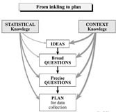](https://www.stat.auckland.ac.nz/~wild/StatThink/images/99.Inkling.png)

**From Inkling to Plan**

Download as a [png](https://www.stat.auckland.ac.nz/~wild/StatThink/images/99.Inkling.png) or an [eps](https://www.stat.auckland.ac.nz/~wild/StatThink/images/99.Inkling.eps)

[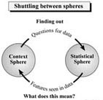](https://www.stat.auckland.ac.nz/~wild/StatThink/images/99.Shuttling.png)

**Shuttling between the spheres**

Download as a [png](https://www.stat.auckland.ac.nz/~wild/StatThink/images/99.Shuttling.png) or an [eps](https://www.stat.auckland.ac.nz/~wild/StatThink/images/99.Shuttling.eps)

[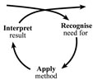](https://www.stat.auckland.ac.nz/~wild/StatThink/images/99.Technique.png)

**Using any technique**

Download as a [png](https://www.stat.auckland.ac.nz/~wild/StatThink/images/99.Technique.png) or an [eps](https://www.stat.auckland.ac.nz/~wild/StatThink/images/99.Technique.eps)

[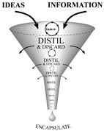](https://www.stat.auckland.ac.nz/~wild/StatThink/images/99.DistilEncaps.png)

**Distillation and Encapsulation**  
Download as a [png](https://www.stat.auckland.ac.nz/~wild/StatThink/images/99.DistilEncaps.png) or an [eps](https://www.stat.auckland.ac.nz/~wild/StatThink/images/99.DistilEncaps.eps)

[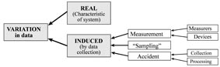](https://www.stat.auckland.ac.nz/~wild/StatThink/images/99.Variation1.png)

**Sources of variation in data**  
Download as a  [png](https://www.stat.auckland.ac.nz/~wild/StatThink/images/99.Variation1.pdf) or an [eps](https://www.stat.auckland.ac.nz/~wild/StatThink/images/99.Variation1.eps)

[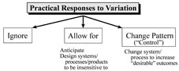](https://www.stat.auckland.ac.nz/~wild/StatThink/images/99.Variation2.png)

**Practical responses to variation**  
Download as a [png](https://www.stat.auckland.ac.nz/~wild/StatThink/images/99.Variation2.png) or an [eps](https://www.stat.auckland.ac.nz/~wild/StatThink/images/99.Variation2.eps)

[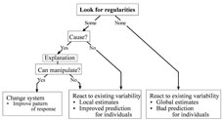](https://www.stat.auckland.ac.nz/~wild/StatThink/images/99.Variation3.png)

**Investigating variability**  
Download as a [png](https://www.stat.auckland.ac.nz/~wild/StatThink/images/99.Variation3.png) or an [eps](https://www.stat.auckland.ac.nz/~wild/StatThink/images/99.Variation3.eps)

[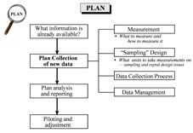](https://www.stat.auckland.ac.nz/~wild/StatThink/images/99.DrillPlan.png)

**Drilling down into Plan**  
Download as a [png](https://www.stat.auckland.ac.nz/~wild/StatThink/images/99.DrillPlan.png) or an [eps](https://www.stat.auckland.ac.nz/~wild/StatThink/images/99.DrillPlan.eps)

[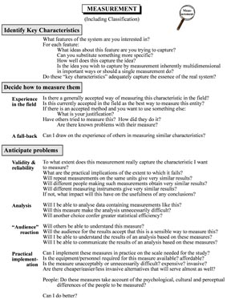](https://www.stat.auckland.ac.nz/~wild/StatThink/images/99.Measurement.png)

**Drilling down into Measurement within Plan**  
Download as a [png](https://www.stat.auckland.ac.nz/~wild/StatThink/images/99.Measurement.png) or an [eps](https://www.stat.auckland.ac.nz/~wild/StatThink/images/99.Measurement.eps) or a [pdf](https://www.stat.auckland.ac.nz/~wild/StatThink/images/99.Measurement.pdf)

**From:**: Wild, Chris (2006). [The concept of distribution"](http://www.stat.auckland.ac.nz/~iase/serj/SERJ5(2)_Wild.pdf), **Statistics Education Research Journal**, 5(2), 10-26.  
  
[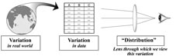](https://www.stat.auckland.ac.nz/~wild/StatThink/images/06.DistrLens.png)

**"Distribution" as a lens**  
Download as a [png](https://www.stat.auckland.ac.nz/~wild/StatThink/images/06.DistrLens.png) or an [eps](https://www.stat.auckland.ac.nz/~wild/StatThink/images/06.DistrLens.eps)

[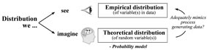](https://www.stat.auckland.ac.nz/~wild/StatThink/images/06.EmpVsTheoret.png)

**Empirical versus theoretical distributions**  
Download as a [png](https://www.stat.auckland.ac.nz/~wild/StatThink/images/06.EmpVsTheoret.png) or an [eps](https://www.stat.auckland.ac.nz/~wild/StatThink/images/06.EmpVsTheoret.eps)

[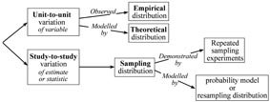](https://www.stat.auckland.ac.nz/~wild/StatThink/images/06.IncorpSamplDistr.png)

**Incorporating the sampling distribution**  
Download as a [png](https://www.stat.auckland.ac.nz/~wild/StatThink/images/06.IncorpSamplDistr.png) or an [eps](https://www.stat.auckland.ac.nz/~wild/StatThink/images/06.IncorpSamplDistr.eps)

**From:**: Wild, Chris, "Virtual Environments and the Acceleration of Experiential Learning", **International Statistical Review**, 75, 322-335, 2007.  
[Thumbnail](https://www.stat.auckland.ac.nz/~wild/StatThink/images/07.Connections.png)

**Making Connections**  
Download as a [png](https://www.stat.auckland.ac.nz/~wild/StatThink/images/07.Connections.png) or an [eps](https://www.stat.auckland.ac.nz/~wild/StatThink/images/07.Connections.eps)

## Miscellaneous from recent talks

Used in the reading at the RSS in London on World Statistics Day (20/10/2010) of Wild, C.J., M. Pfannkuch, M., Regan, M. and Horton, N.J. (2011) Towards more accessible conceptions of statistical Inference. **Journal of the Royal Statistical Society A**, in press.

**World through Glass 1**  
Download as a [png](images/10.World%20Through%20Glass1.png)

**World through Glass 2**  
Download as a [png](images/10.World%20Through%20Glass2.png)

Used in the CW's discussion of the papers in the **President's Session of ICOTS 8 in Slovenia July 2010.**  
[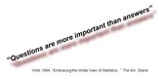](https://www.stat.auckland.ac.nz/~wild/StatThink/images/10.Questions1.png)

**Questions are more important than answers**  
Download as a [png](https://www.stat.auckland.ac.nz/~wild/StatThink/images/10.Questions1.png)

[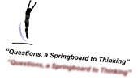](https://www.stat.auckland.ac.nz/~wild/StatThink/images/10.Questions2.Springboard.png)

**Questions: A springboard to thinking**  
Download as a [png](https://www.stat.auckland.ac.nz/~wild/StatThink/images/10.Questions2.Springboard.png)

## Miscellaneous from Teaching

**Stat Man and Stat Woman**: While these are not themselves "statistical thinking pictures", when used as characters who ask habitual statistical questions (e.g. "Real of random?") or giving routinely repeated statsitical answers they can form building blocks for fostering statistical thinking habits of mind.   
[](https://www.stat.auckland.ac.nz/~wild/StatThink/images/statman-up.png)

**Stat Man up**  
Download as a [png](https://www.stat.auckland.ac.nz/~wild/StatThink/images/statman-up.png) or [pdf](https://www.stat.auckland.ac.nz/~wild/StatThink/images/statman-up.pdf) or [eps](https://www.stat.auckland.ac.nz/~wild/StatThink/images/statman-up.eps)

[](https://www.stat.auckland.ac.nz/~wild/StatThink/images/statman-down.png)

**Stat Man down**  
Download as a [png](https://www.stat.auckland.ac.nz/~wild/StatThink/images/statman-down.png) or [pdf](https://www.stat.auckland.ac.nz/~wild/StatThink/images/statman-down.pdf) or [eps](https://www.stat.auckland.ac.nz/~wild/StatThink/images/statman-down.eps)

[](https://www.stat.auckland.ac.nz/~wild/StatThink/images/statwoman-up.png)

**Stat Woman up**  
Download as a [png](https://www.stat.auckland.ac.nz/~wild/StatThink/images/statwoman-up.png) or [pdf](https://www.stat.auckland.ac.nz/~wild/StatThink/images/statwoman-up.pdf) or [eps](https://www.stat.auckland.ac.nz/~wild/StatThink/images/statwoman-up.eps)

[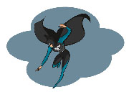](https://www.stat.auckland.ac.nz/~wild/StatThink/images/statwoman-down.png)

Stat Woman down  
Download as a [png](https://www.stat.auckland.ac.nz/~wild/StatThink/images/statwoman-down.png) or [pdf](https://www.stat.auckland.ac.nz/~wild/StatThink/images/statwoman-down.pdf) or [eps](https://www.stat.auckland.ac.nz/~wild/StatThink/images/statwoman-down.eps)

/var/folders/4q/_168gj4x40l9t_x1x1pk0f700000gn/T/com.microsoft.Word/WebArchiveCopyPasteTempFiles/eye.jpg

***Stat Think - "The Eyes have it"***